Arys, Str. Akkozova,29/2 Mob : +77714150699

e-mail :muhabbatullah@mail.ru

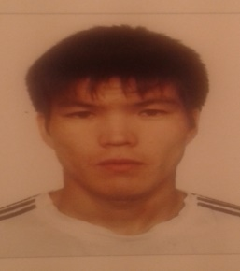

**CV**

**Shapanbayev Bakhtiyar**

**Personal information**

* **Birth day** 29 march 1991 year
* **Marital status** single
* **Nationality** Kazakh

**Education**

Kazakh Gymnasium school

2009-2013 *Kazakh national technical university named after K.I. Satbayev*, the degree of ***Bachelor* 050709 «metallurgy»**

2011-2013  *Moscow State University of Fine Chemical Technologies named after M.V. Lomonosov*, the degree of **master degree 240100 «Processes and devices of chemical technology»**

**Computer skills**

* OC WINDOWS
* Microsoft office
* Internet

**Languages**

**Kazakh** – native,

**Russian** – fluent,

**English** – intermediate

**Turkish** – beginner

**Experience**

2013.Pre-diploma practice LLP "**Altyntau Kokshetau**", Kokshetau

2011 internship JSC "**KazSHPAL**", Astana

2012 Manufacturing practice LLP "**Altyntau Kokshetau**", Kokshetau

2015 length of service **Minisry of energy RK**

**Personal Skills** Responsible, hardworking, able to work in tearn and individual, punctual, conscientious, kind.